SENG 21253 WEB DEVELOPMENT PROJECT REPORT

R.M.N.P.B.Ramanayake

SE/2014/058

**Index**

Problem ------------------------------------------------------------------------3

Solution-------------------------------------------------------------------------4

1. Home page------------------------------------------------------4
2. Log page---------------------------------------------------------8
3. Home page------------------------------------------------------9
4. Services page--------------------------------------------------11
5. Rate page------------------------------------------------------13
6. About page----------------------------------------------------16
7. Contact page--------------------------------------------------17

Source code------------------------------------------------------------------18

signup.php-------------------------------------------------------------------18

log.php------------------------------------------------------------------------26

home.php--------------------------------------------------------------------31

services.php-----------------------------------------------------------------38

rate.php----------------------------------------------------------------------47

about.php--------------------------------------------------------------------59

contact.php------------------------------------------------------------------66

JS Codes

main2.js----------------------------------------------------------------------73

Css codes

Style.css----------------------------------------------------------------------78

PHP Codes

Dbh.inc.php---------------------------------------------------------------106

Signup.inc.php------------------------------------------------------------106

Log.inc.php----------------------------------------------------------------109

Data base------------------------------------------------------------------114

**Problem**

Ramanayake Travels Pvt.Ltd is a leading vehicle renting company with over 8 years of experience in the industry, they strive to offer the highest levels of customer service and a highly personalized service to all our customers who are on the lookout for Sri Lanka car rental opportunities.

But the main problem they were faced was they didn’t owned their own web site with them .So, to solve that problem we came up with a solution which is consist with several html,css,php,java script,my sql data base

**Solution**

The solution is mainly consist with several several html,css, my sql data base ,php,java script, source code pages.this part of this project is to describe about that source code

1**. Sign-up page(index.php)**

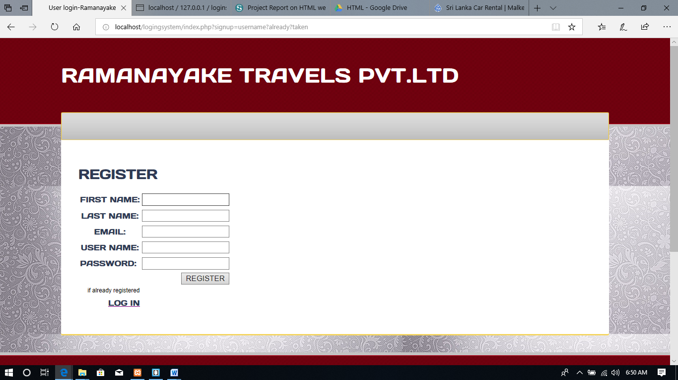

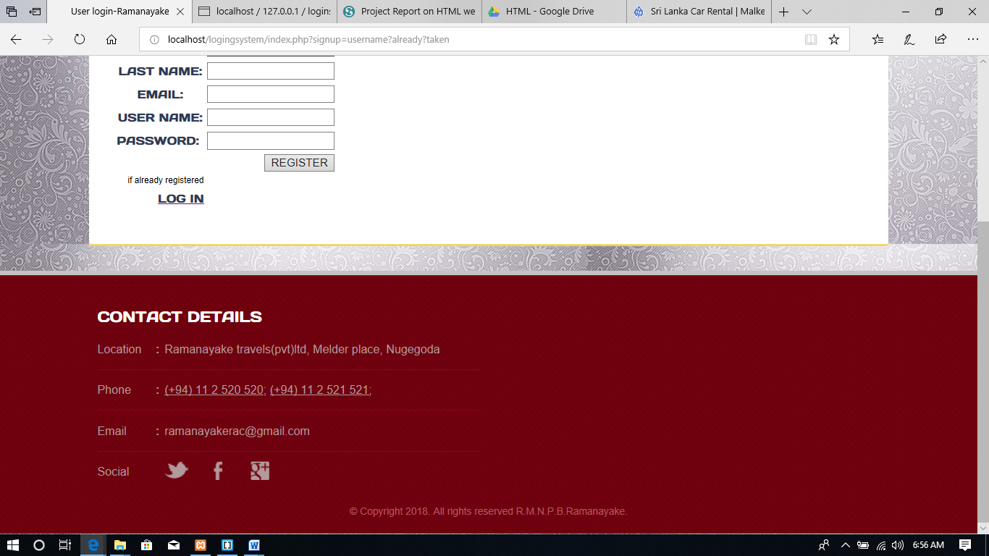

Description main functionalities:

In this page user have main 2 options .one is to enter the fields and register and other option is Log in for the already registered users(by clicking that link will direct to the log in page)

In the footer division it is consist with main information of the copanay.In the social media part it is consist with icon of twitter,facebook,google+ which are linked to the respective web sites

To register ,the user should fill all the detail.in the **main2.js** java script file is validating the user inputs .If user forgot to enter any of these field, an alert box will be poped up.

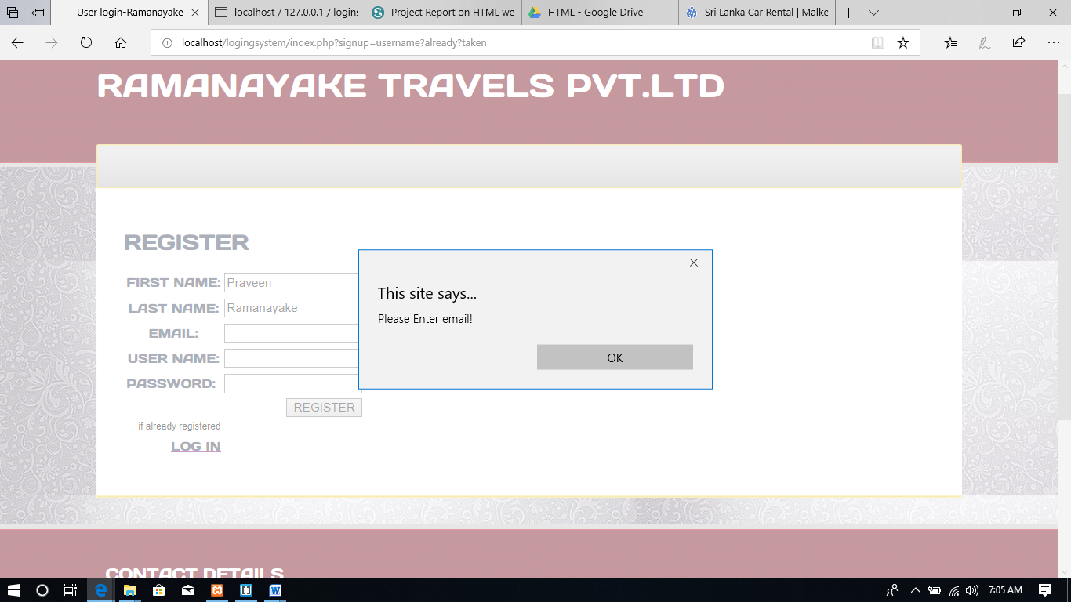

.And even though the user entered all the fields, the e-mail is validate by another java script function (in **main2.js** ).

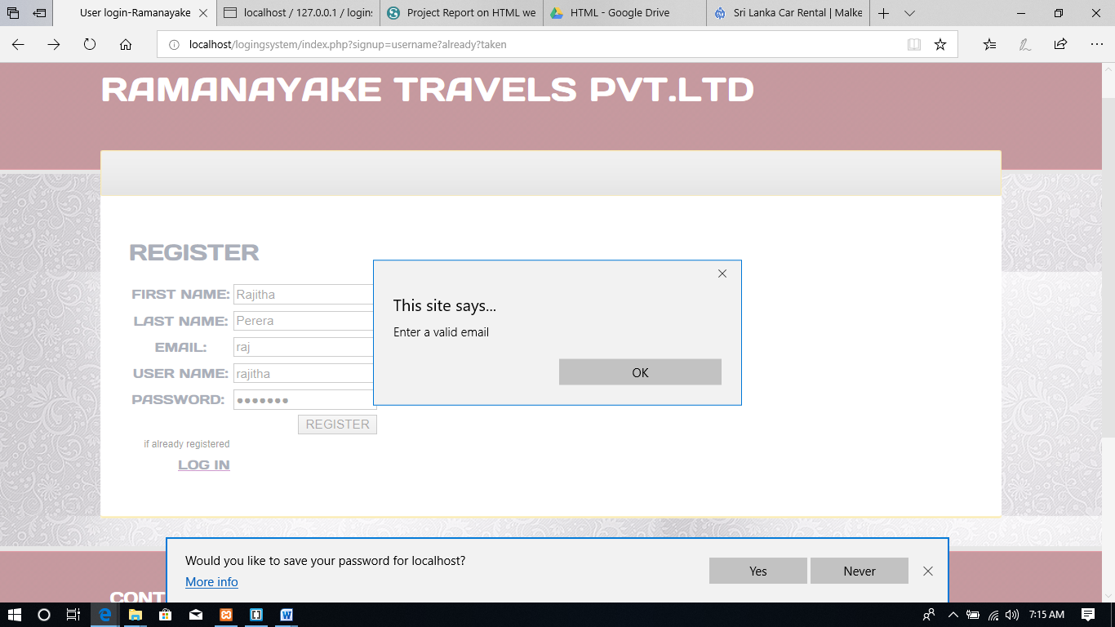

And the functionality is its prohibited to enter a username which is already taken by another user.and it will send back to the register page(**index.php**)

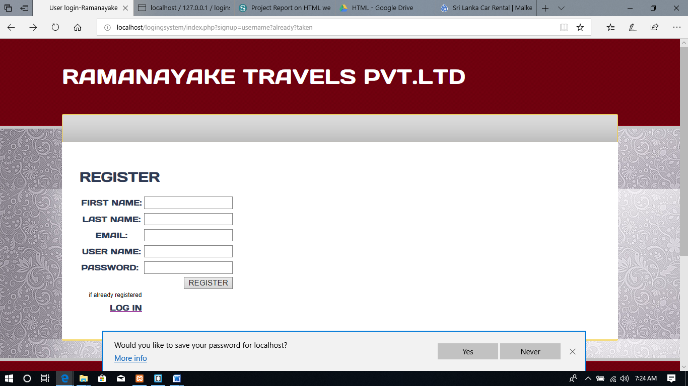

If user enter all the data the data correctly the **signup.inc.php(**inside the include folder) php file will store it in the data base and direct to the home page.

Prior to do this the data base should be created.

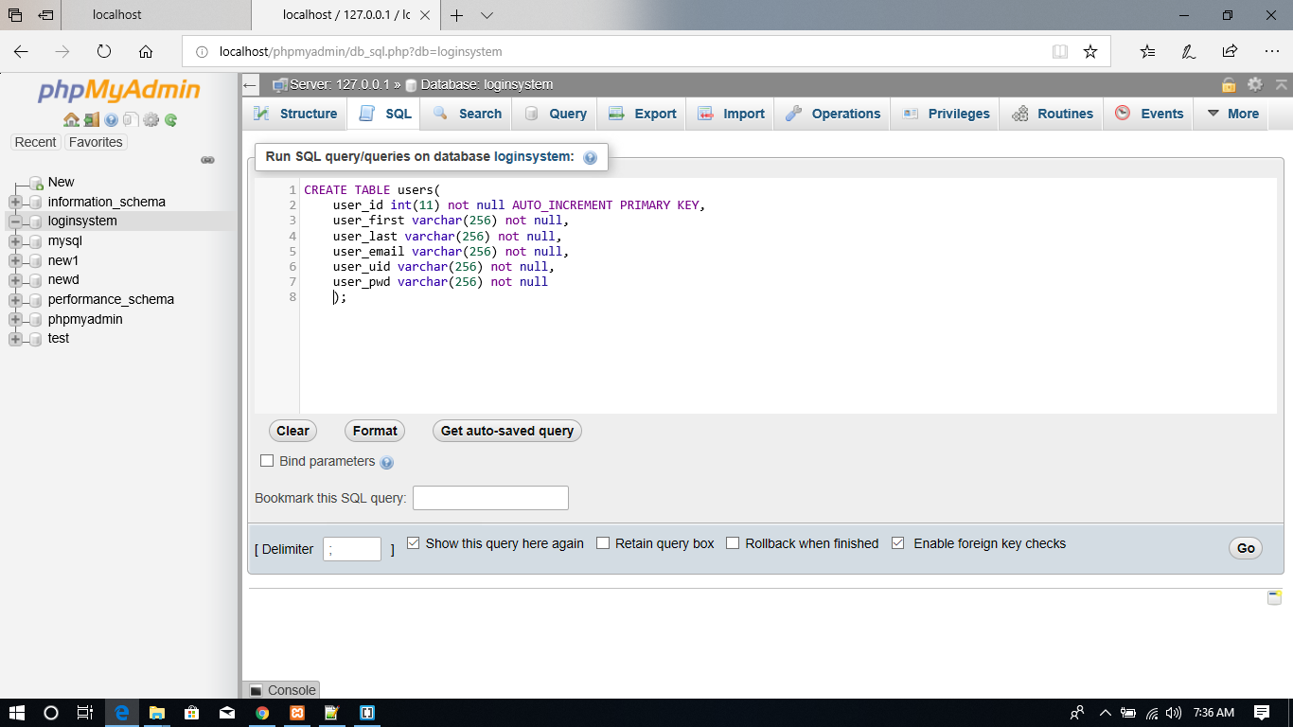

2.**Log in page**(**log.php**)

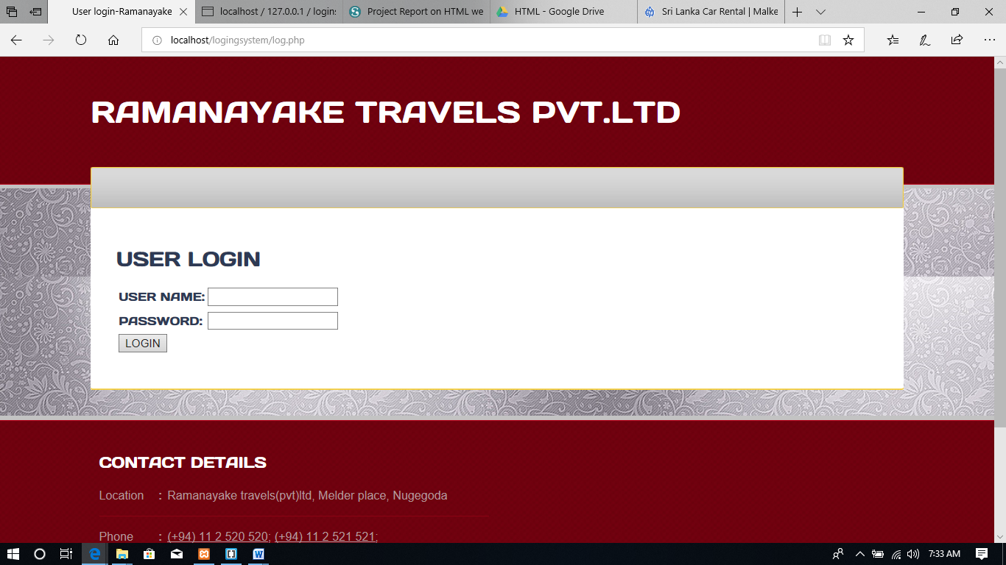

If the user click the log in link in register(index.php)page user will be direct to this log in page(**log.php)**

In this page also the fields are validated by **main2.js** java script file

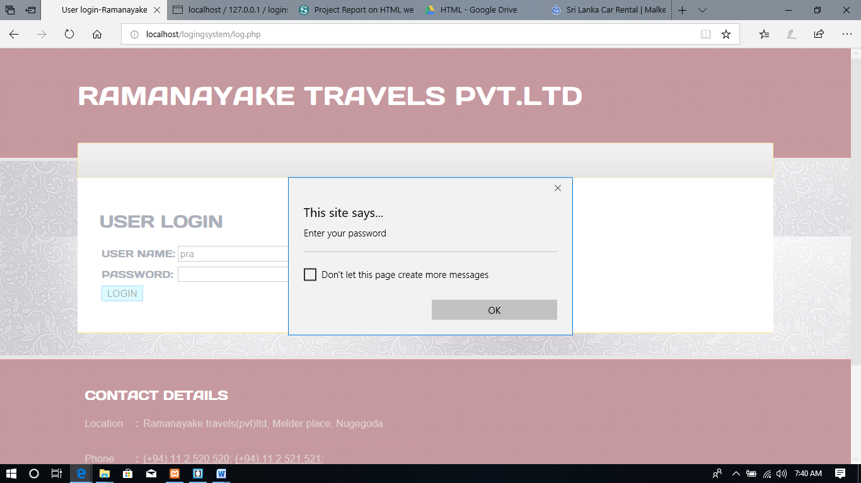

After user enter valid password and a user name ,the **log.inc.php** (inside the include folder)file will compare it with the data base.and after thatit will direct to the home page(**home.php**).

3. **Home page(home.php)**

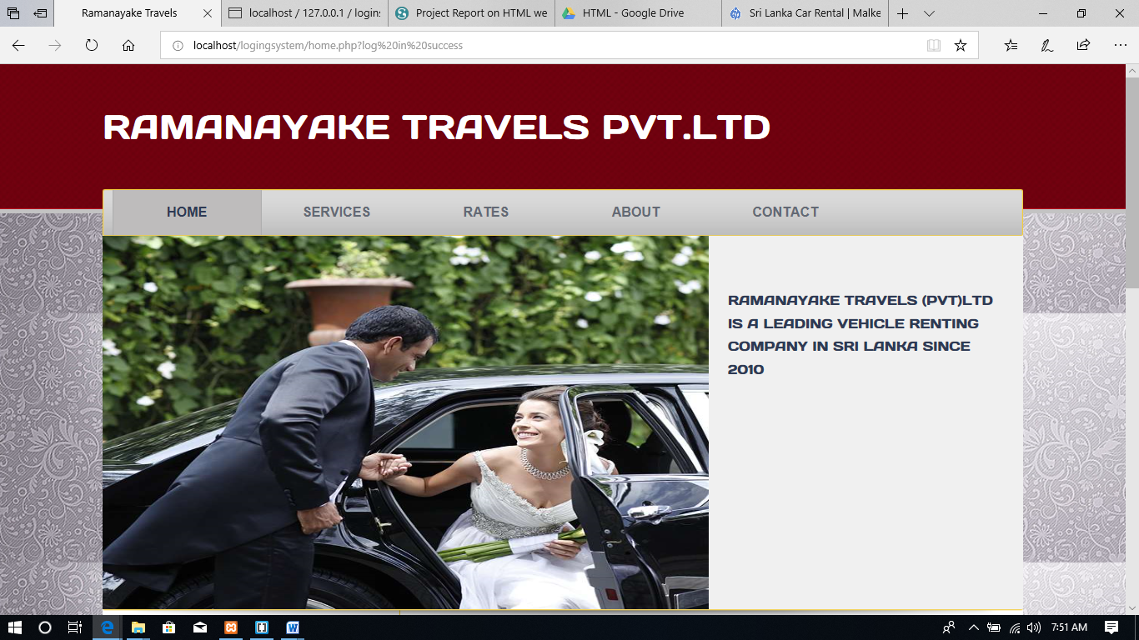

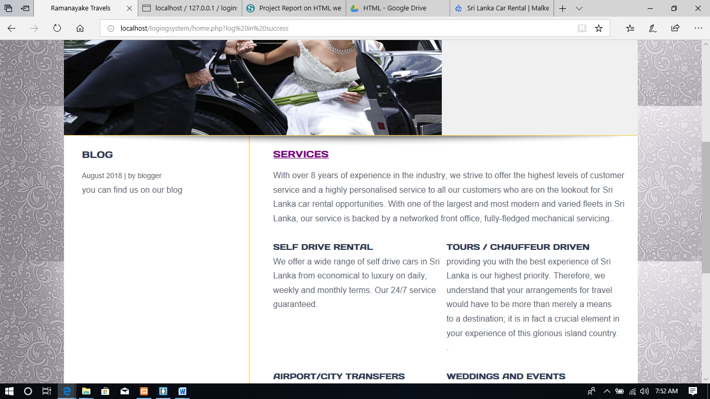

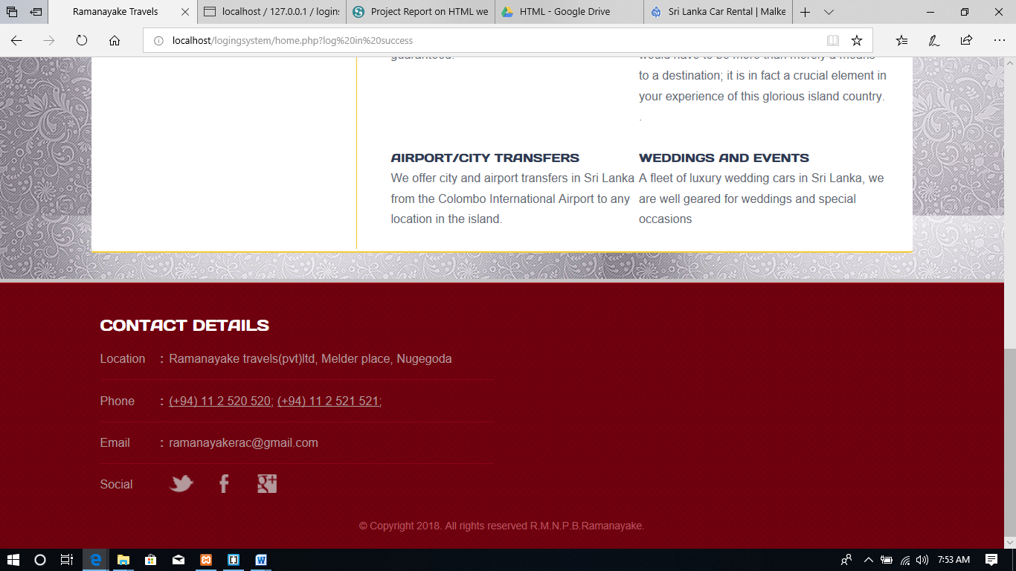

**4.Services page(service.php)**

This page is consist with main information about the company any and their services.

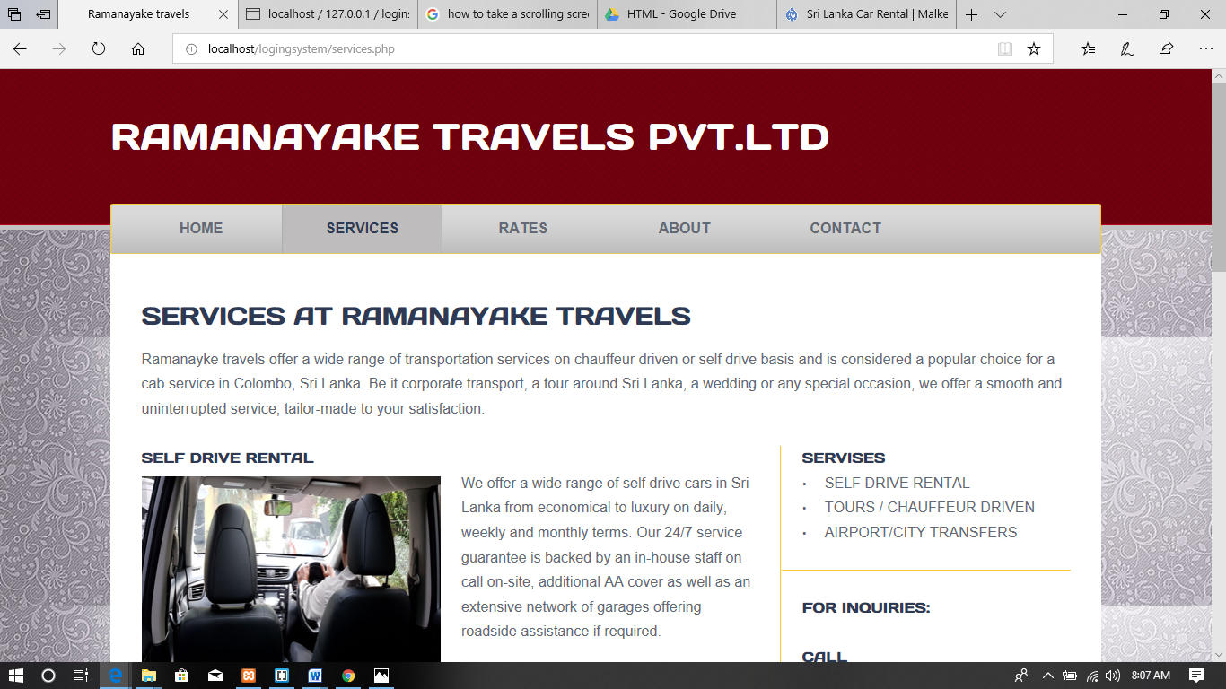

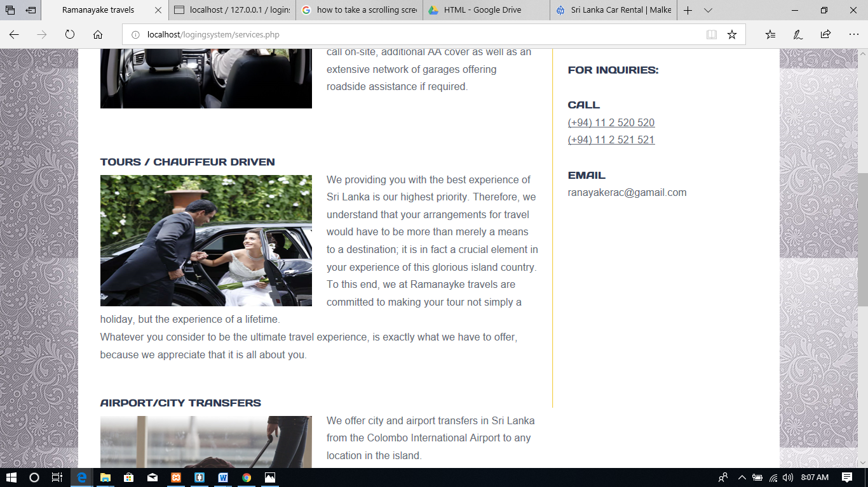

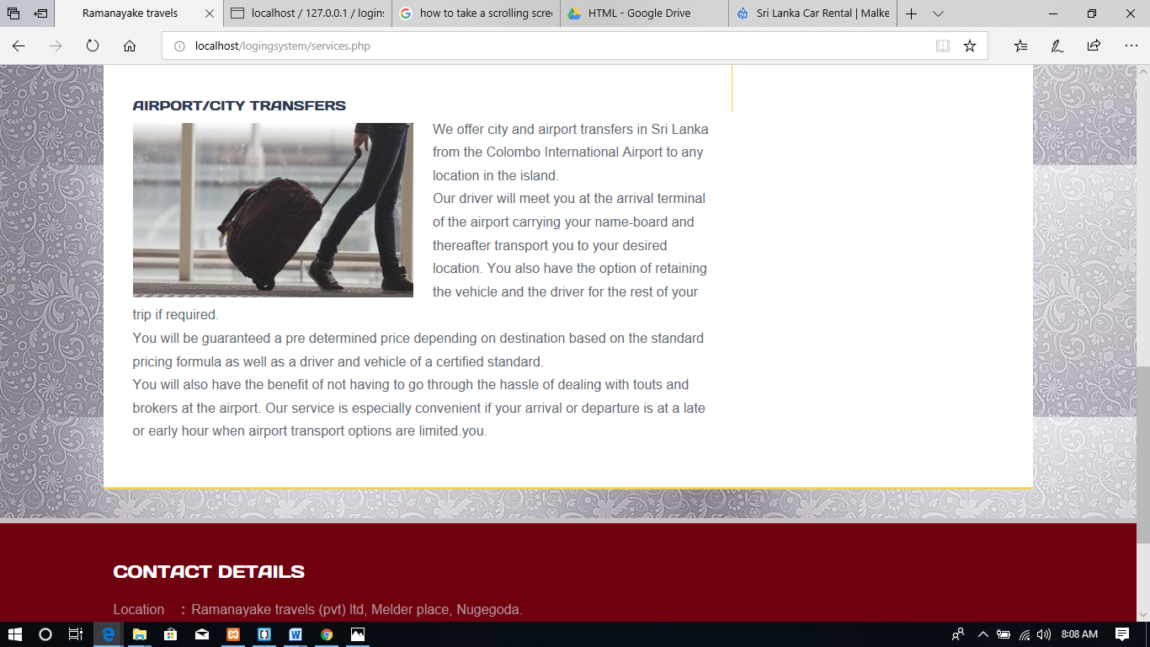

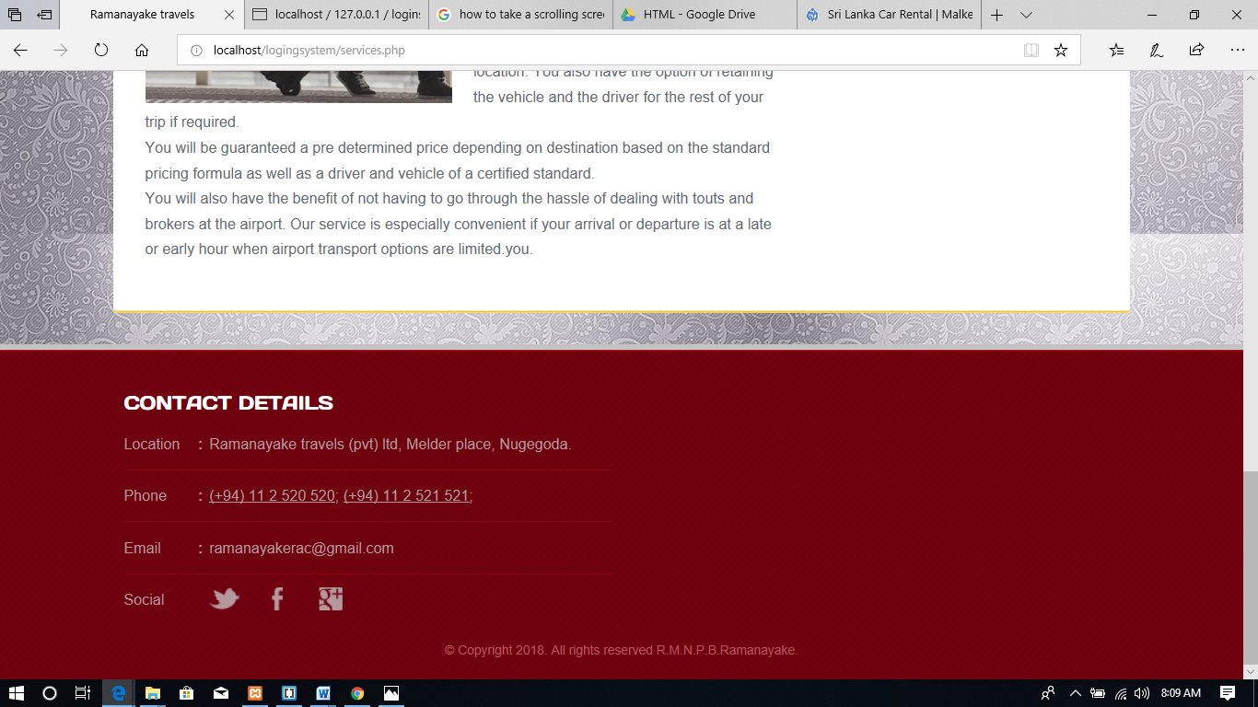

5**. Rates Page(rates.php)**

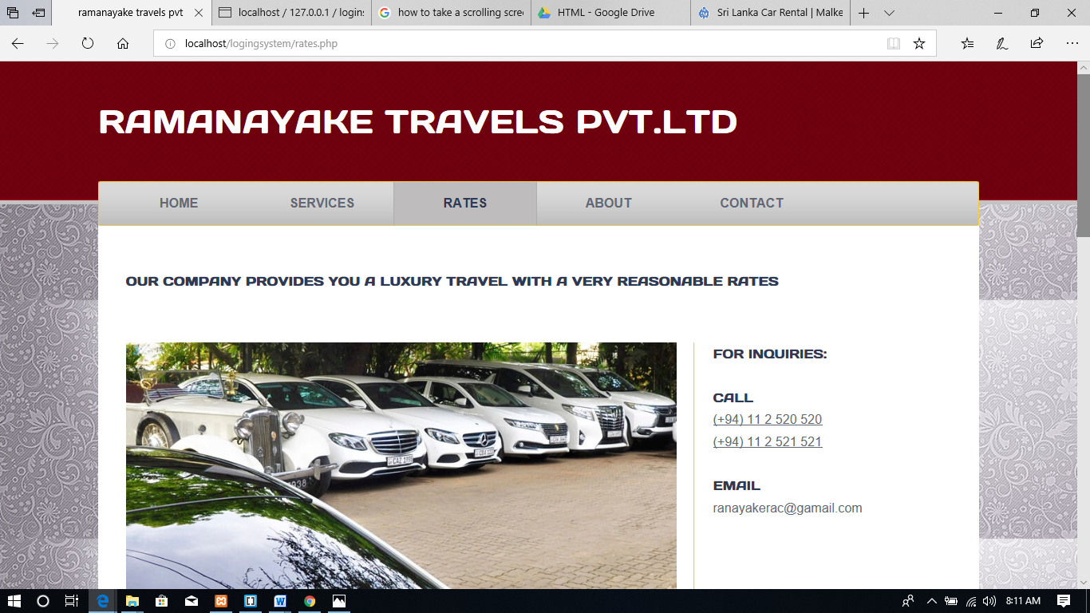

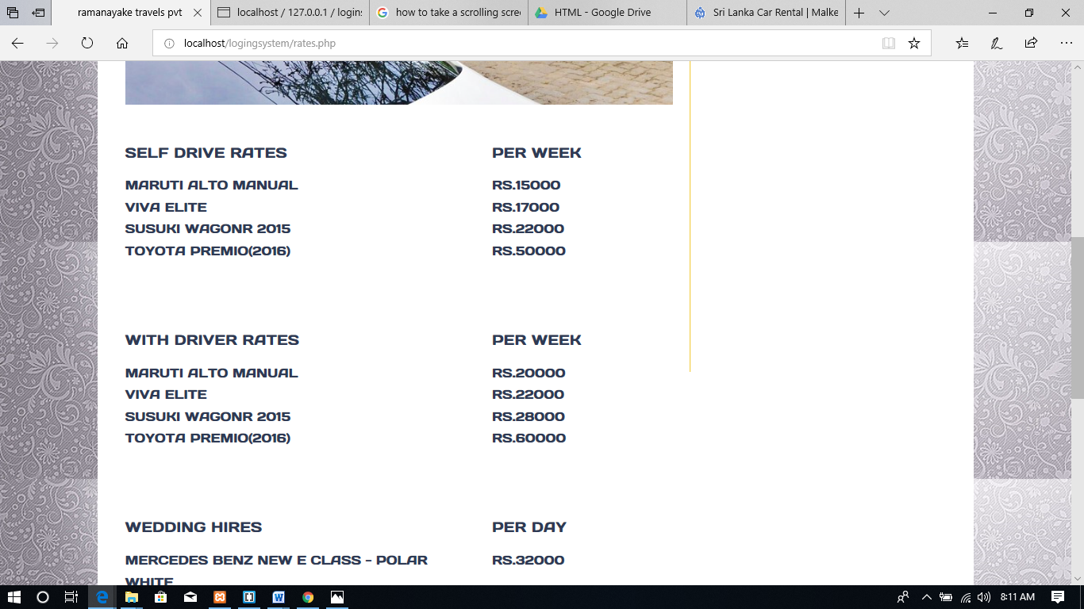

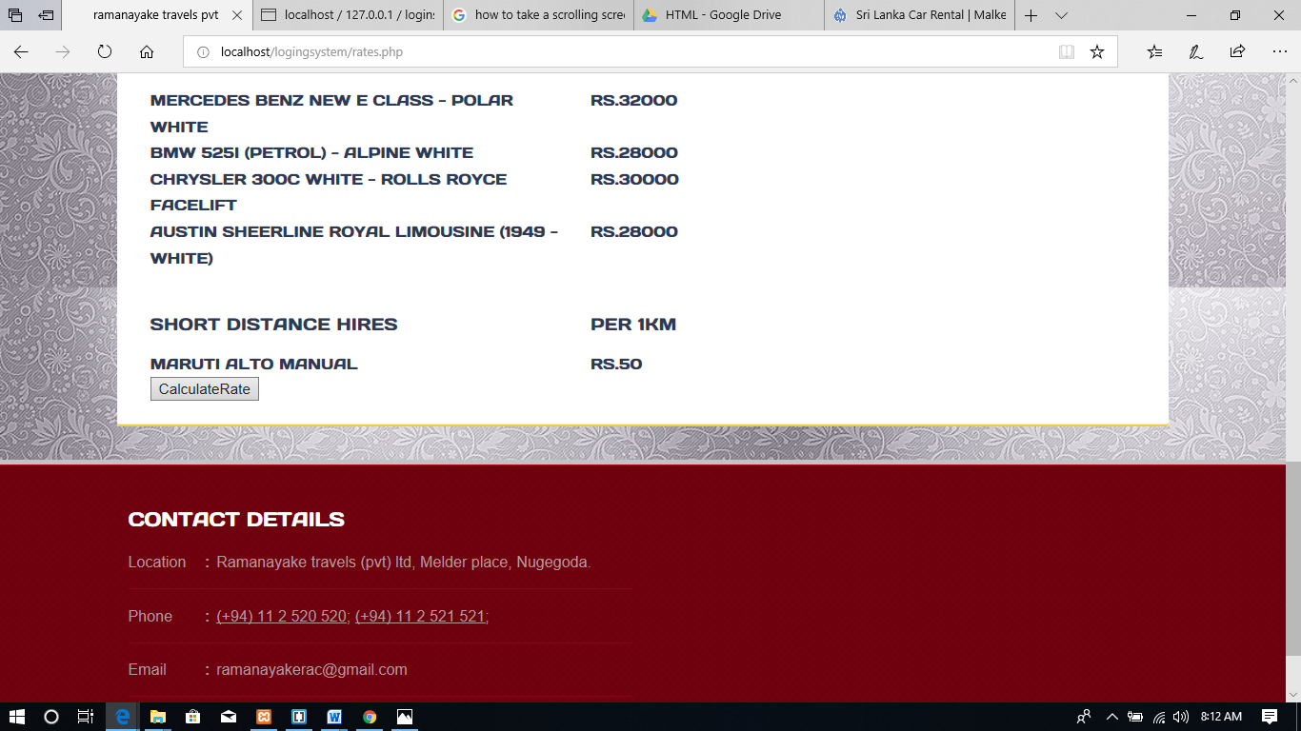

This page is consist with all the rent charges of this company. And the bottom of the page there is a **button call calculate rate** .the main function of it is to calculate a estimate charge for a short term distance hire after user entering a distance in kms. It is coded with java script **main2.js** file**.**

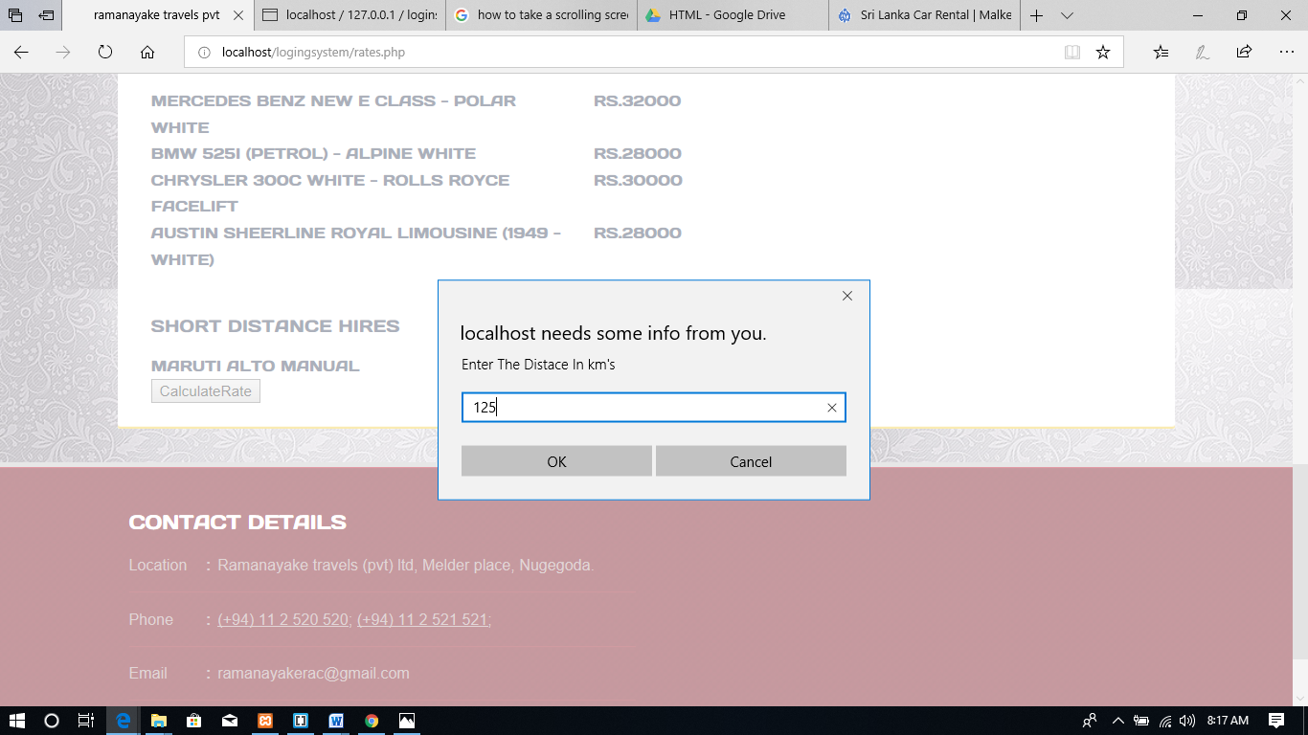

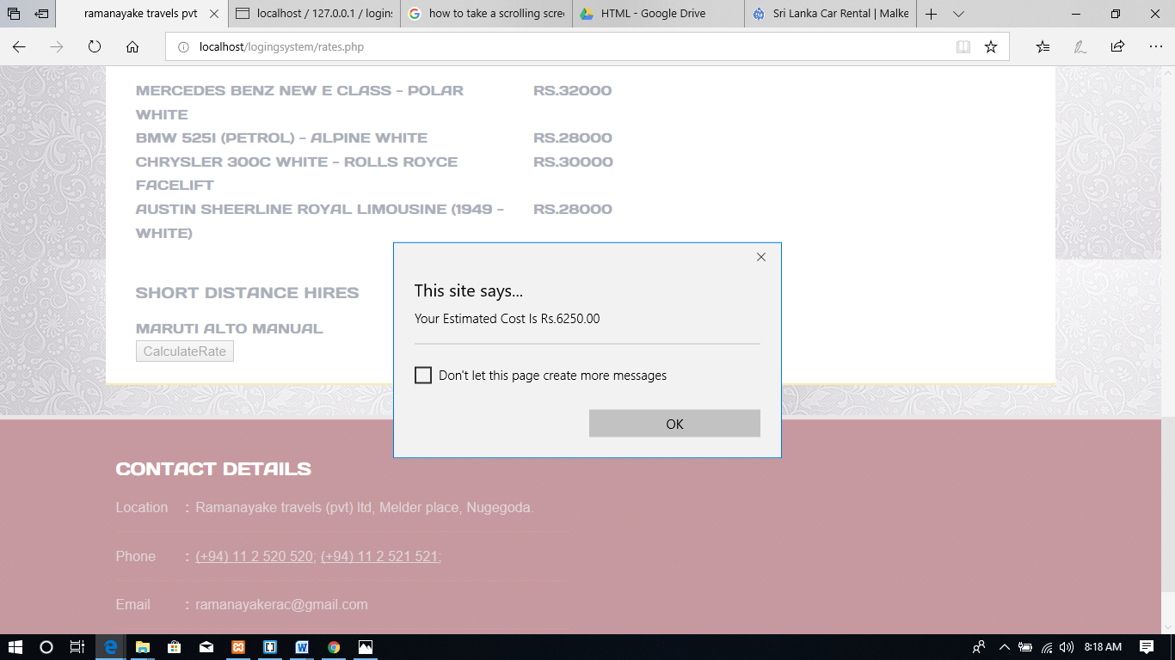

**6.About page(about.php)**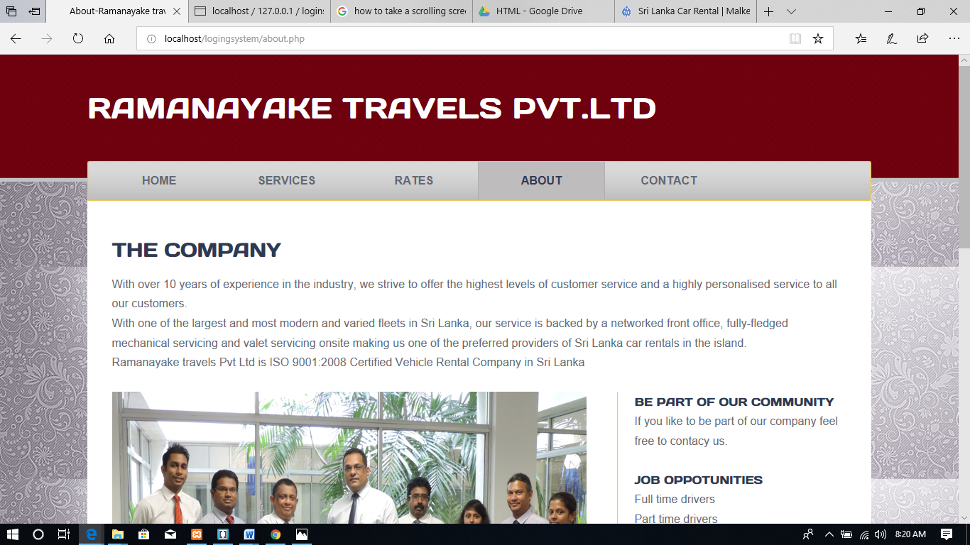 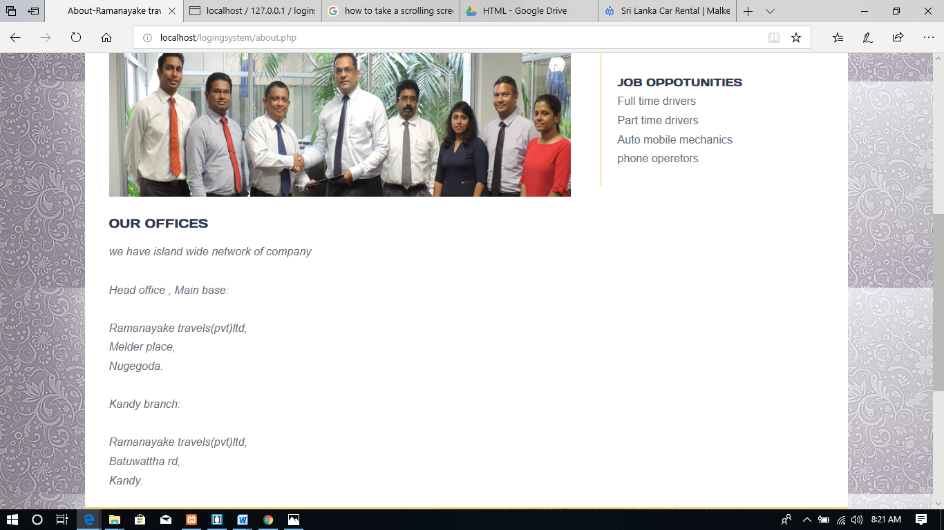

this page is consist with all the detais about the company.job opportunities ,location of offices,and the history about the company.

**7.Contact Page(contact.php)**

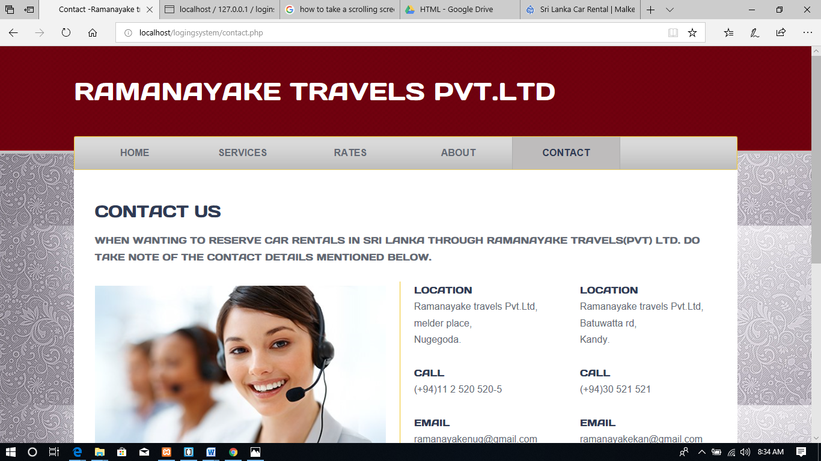 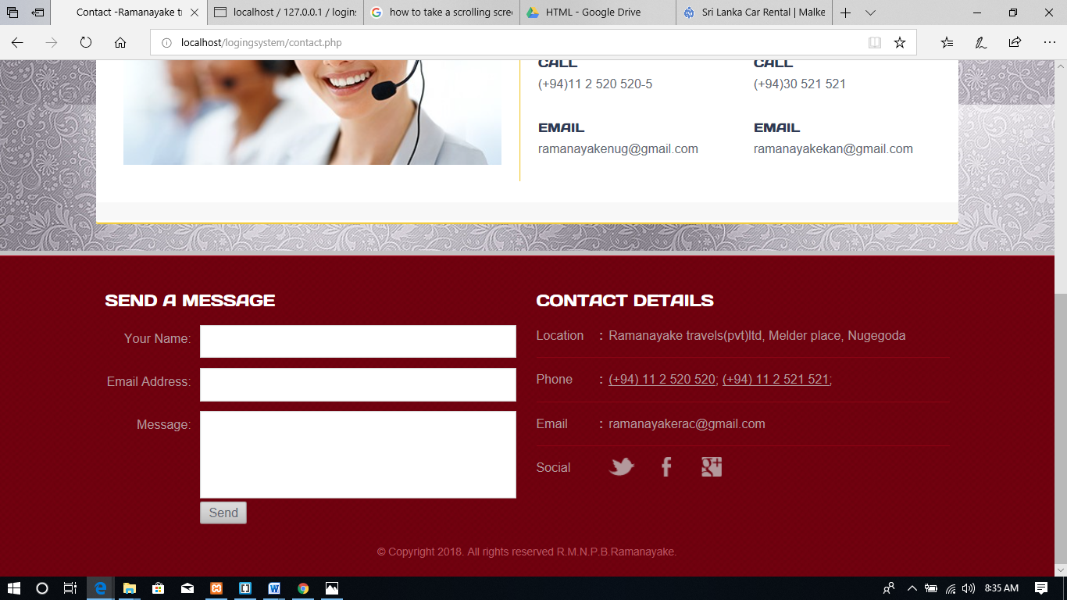

In this page it is consist with all the contact details of the company. And in the latter part of the page it is consist of a send a message form which is again validated by **main2.js** file 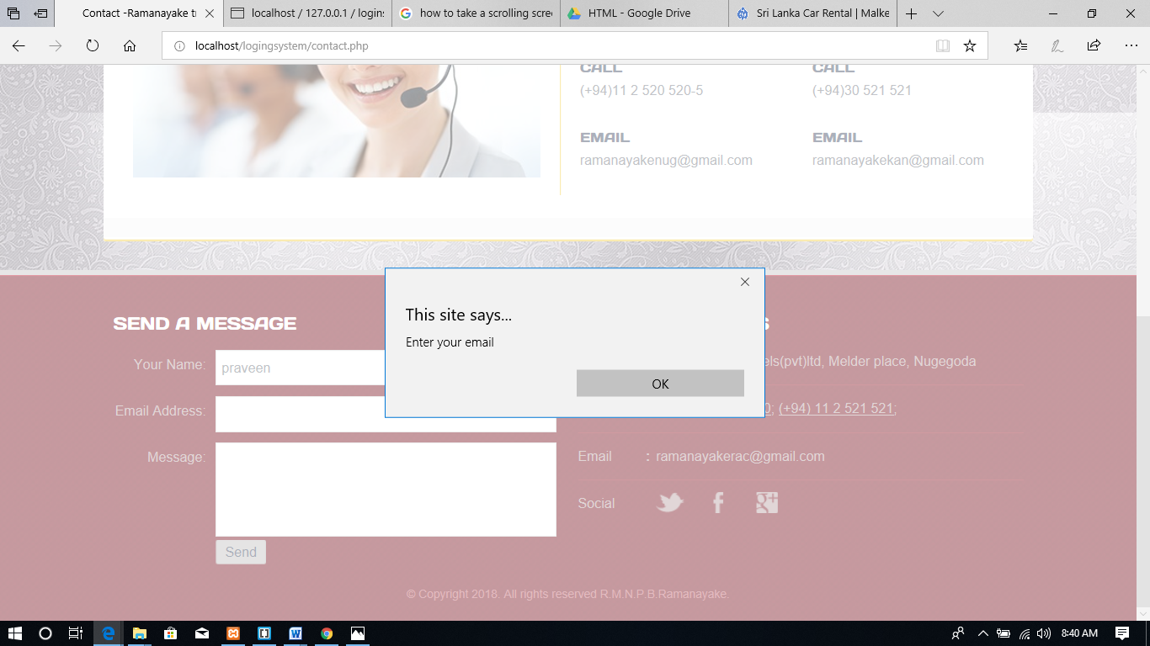

After user enter valid information to the text fields it is directed to the data base(loginsystem data base->message table)

***(full Code for Data base is included in 114 page)***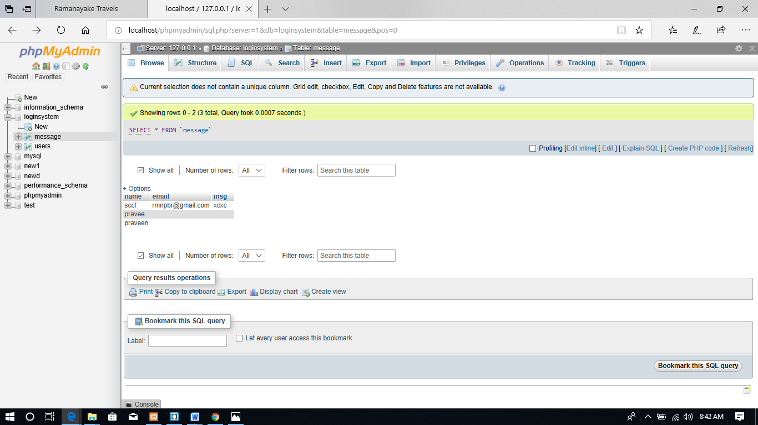

This is done by **contmsg.php** file.The data base and the table should be created earlier.

**Sourse codes**

**Index.php**

<!DOCTYPE html>

<html>

<head>

<meta charset="UTF-8">

<title>User login-Ramanayake travels</title>

<link rel="stylesheet" href="css/style.css" type="text/css">

<script type="text/javascript" src="javascript/main2.js"></script>

</head>

<body>

<div id="page">

<div id="header">

<div class="background">

<h1 id="logo"> <a>ramanayake travels pvt.ltd</a> </h1>

<div id="navigation">

</div>

</div>

</div>

<div id="contents">

<div id="about">

<h2>register</h2>

<form action="include/signup.inc.php" method="POST">

<table >

<tr>

<th><h5>first name:</h5></th>

<td>

<input type="text" name="fname"id="fname">

</tr>

<tr>

<th><h5>last name:</h5></th>

<td>

<input type="text" name="lname"id="lname">

</td>

</tr>

<tr>

<th><h5>email:</h5></th>

<td>

<input type="text" name="email"id="email">

</td>

</tr>

<tr>

<th><h5>user name:</h5></th>

<td>

<input type="text" name="uid"id="uid">

</td>

</tr>

<tr>

<td>

<h5>password:</h5>

</td>

<td>

<input type="password" name="pwd"id="pwd">

</td>

<tr>

<td colspan="2">

<input type="submit" name="submit"

value="REGISTER" style="float: right" onclick="return validateform()"> </td>

</tr>

<tr>

<td colspan="2" style="float: right;font-size:65%;">

<span>if already registered</span>

</td>

</tr>

<tr>

<td colspan="2" style="float: right">

<span><a href="log.php"><h5>LOG IN</h5></a></span>

</td>

</tr>

</table>

</form>

<div id="main">

<h2></h2>

<address>

<p>

</p>

</address>

</div>

</div>

</div>

<div id="footer">

<div class="background">

<div class="body">

<div class="section">

<h3>Contact Details</h3>

<ul>

<li>

<span>Location</span><strong>:</strong>

<p>

Ramanayake travels(pvt)ltd, Melder place, Nugegoda

</p>

</li>

<li>

<span>Phone</span><strong>:</strong>

<p>

(+94) 11 2 520 520; (+94) 11 2 521 521;

</p>

</li>

<li>

<span>Email</span><strong>:</strong>

<p>

ramanayakerac@gmail.com

</p>

</li>

<li>

<span>Social</span><a href="https://twitter.com/?lang=en" target="_blank" class="twitter"></a><a href="https://www.facebook.com/ramanayake.rentacar.3" target="_blank" class="facebook"></a><a href="https://plus.google.com/discover" target="_blank" class="googleplus"></a>

</li>

</ul>

</div>

<p id="footnote">

© Copyright 2018. All rights reserved R.M.N.P.B.Ramanayake.

</p>

</div>

</div>

</div>

</div>

</body>

</html>

**Log.php**

<?php

session_start();

?>

<!DOCTYPE html>

<html>

<head>

<meta charset="UTF-8">

<title>User login-Ramanayake travels</title>

<link rel="stylesheet" href="css/style.css" type="text/css">

<script type="text/javascript" src="javascript/main2.js"></script>

</head>

<body>

<div id="page">

<div id="header">

<div class="background">

<h1 id="logo"> <a>ramanayake travels pvt.ltd </a></h1>

<div id="navigation">

</div>

</div>

</div>

<div id="contents">

<div id="about">

<h2>user login</h2>

<form action="include/log.inc.php" method="post">

<table>

<tr>

<th><h5>user name:</h5></th>

<td>

<input type="text" name="uid" id="uid">

</td>

</tr>

<tr>

<td>

<h5>password:</h5>

</td>

<td>

<input type="password" name="pwd" id="pwd">

</td>

<tr>

<td colspan="2">

<input type="submit" value="LOGIN" onclick="return validatelog()"> </td>

</tr>

</table>

</form>

<div id="main">

<h2></h2>

<address>

<p>

</p>

</address>

</div>

</div>

</div>

<div id="footer">

<div class="background">

<div class="body">

<div class="section">

<h3>Contact Details</h3>

<ul>

<li>

<span>Location</span><strong>:</strong>

<p>

Ramanayake travels(pvt)ltd, Melder place, Nugegoda

</p>

</li>

<li>

<span>Phone</span><strong>:</strong>

<p>

(+94) 11 2 520 520; (+94) 11 2 521 521;

</p>

</li>

<li>

<span>Email</span><strong>:</strong>

<p>

ramanayakerac@gmail.com

</p>

</li>

<li>

<span>Social</span><a href="https://twitter.com/?lang=en" target="_blank" class="twitter"></a><a href="https://www.facebook.com/ramanayake.rentacar.3" target="_blank" class="facebook"></a><a href="https://plus.google.com/discover" target="_blank" class="googleplus"></a>

</li>

</ul>

</div>

<p id="footnote">

© Copyright 2018. All rights reserved R.M.N.P.B.Ramanayake.

</p>

</div>

</div>

</div>

</div>

</body>

</html>

**Home.php**

<?php

session_start();

?>

<!DOCTYPE html>

<html>

<head>

<meta charset="UTF-8">

<title>Ramanayake Travels</title>

<link rel="stylesheet" href="css/style.css" type="text/css">

</head>

<body>

<div id="page">

<div id="header">

<div class="background">

<div>

<h1 id="logo"> <a href="home.php">ramanayake Travels pvt.ltd</a> </h1></div>

<div id="navigation">

<ul>

<li class="selected">

<a href="home.php">Home</a>

</li>

<li>

<a href="services.php">Services</a>

</li>

<li>

<a href="rates.php">Rates</a>

</li>

<li>

<a href="about.php">About</a>

</li>

<li>

<a href="contact.php">Contact</a>

</li>

</ul>

</div>

</div>

</div>

<div id="contents">

<div id="adbox">

<div>

<img src="images/bride-getting-out-of-car-1.jpg" alt="Img" height="390" width="632">

<br/><br/><br/>

<h4>Ramanayake travels (pvt)ltd is a leading vehicle renting company in sri lanka since 2010</h4>

</div>

</div>

<div class="sidebar">

<h4>Blog</h4>

<ul>

<li>

<span class="time">August 2018 | by <a href="home.php">blogger</a></span> <a href="https://www.blogger.com/about/?r=2">you can find us on our blog</a>

</li>

</ul>

</div>

<div id="main">

<h4><a href="services.php">Services</a></h4>

<p>

With over 8 years of experience in the industry, we strive to offer the highest levels of customer service and a highly personalised service to all our customers who are on the lookout for Sri Lanka car rental opportunities. With one of the largest and most modern and varied fleets in Sri Lanka, our service is backed by a networked front office, fully-fledged mechanical servicing..

</p>

<ul>

<li>

<p>

<b>SELF DRIVE RENTAL</b> We offer a wide range of self drive cars in Sri Lanka from economical to luxury on daily, weekly and monthly terms. Our 24/7 service guaranteed.

</p>

</li>

<li>

<p>

<b>TOURS / CHAUFFEUR DRIVEN</b> providing you with the best experience of Sri Lanka is our highest priority. Therefore, we understand that your arrangements for travel would have to be more than merely a means to a destination; it is in fact a crucial element in your experience of this glorious island country. .

</p>

</li>

<li>

<p>

<b>AIRPORT/CITY TRANSFERS</b> We offer city and airport transfers in Sri Lanka from the Colombo International Airport to any location in the island.

</p>

</li>

<li>

<p>

<b>WEDDINGS AND EVENTS</b> A fleet of luxury wedding cars in Sri Lanka, we are well geared for weddings and special occasions

</p>

</li>

</ul>

</div>

</div>

<div id="footer">

<div class="background">

<div class="body">

<div class="section">

<h3>Contact Details</h3>

<ul>

<li>

<span>Location</span><strong>:</strong>

<p>

Ramanayake travels(pvt)ltd, Melder place, Nugegoda

</p>

</li>

<li>

<span>Phone</span><strong>:</strong>

<p>

(+94) 11 2 520 520; (+94) 11 2 521 521;

</p>

</li>

<li>

<span>Email</span><strong>:</strong>

<p>

ramanayakerac@gmail.com

</p>

</li>

<li>

<span>Social</span><a href="https://twitter.com/?lang=en" target="_blank" class="twitter"></a><a href="https://www.facebook.com/ramanayake.rentacar.3" target="_blank" class="facebook"></a><a href="https://plus.google.com/discover" target="_blank" class="googleplus"></a>

</li>

</ul>

</div>

<p id="footnote">

© Copyright 2018. All rights reserved R.M.N.P.B.Ramanayake.

</p>

</div>

</div>

</div>

</div>

</body>

</html>

**service.php**

<!DOCTYPE html>

<html>

<head>

<meta charset="UTF-8">

<title>Ramanayake travels</title>

<link rel="stylesheet" href="css/style.css" type="text/css">

</head>

<body>

<div id="page">

<div id="header">

<div class="background">

<h1 id="logo"> <a href="home.php">ramanayake travels pvt.ltd</a> </h1>

<div id="navigation">

<ul>

<li>

<a href="home.php">Home</a>

</li>

<li class="selected">

<a href="services.php">Services</a>

</li>

<li>

<a href="rates.php">Rates</a>

</li>

<li>

<a href="about.php">About</a>

</li>

<li>

<a href="contact.php">Contact</a>

</li>

</ul>

</div>

</div>

</div>

<div id="contents">

<div id="services">

<h2>services at ramanayake travels</h2>

<p>

Ramanayke travels offer a wide range of transportation services on chauffeur driven or self drive basis and is considered a popular choice for a cab service in Colombo, Sri Lanka.

Be it corporate transport, a tour around Sri Lanka, a wedding or any special occasion, we offer a smooth and uninterrupted service, tailor-made to your satisfaction.

</p>

<div id="sidebar">

<div class="section">

<h5>servises</h5>

<ul>

<li>

<a href="services.html">SELF DRIVE RENTAL</a>

</li>

<li>

<a href="services.html">TOURS / CHAUFFEUR DRIVEN</a>

</li>

<li>

<a href="services.html">AIRPORT/CITY TRANSFERS</a>

</li>

</ul>

</div>

<div class="section">

<h5>for inquiries:</h5>

<p>

</p>

<h5>CALL</h5>

<p>

(+94) 11 2 520 520<br>(+94) 11 2 521 521

</p>

<h5>Email</h5>

<p>

ranayakerac@gamail.com

</p>

</div>

</div>

<ul class="list">

<li>

<h5>SELF DRIVE RENTAL</h5>

<img src="images/xtrail-d.jpg" alt="Img" height="180" width="290">

<p>We offer a wide range of self drive cars in Sri Lanka from economical to luxury on daily, weekly and monthly terms. Our 24/7 service guarantee is backed by an in-house staff on call on-site, additional AA cover as well as an extensive network of garages offering roadside assistance if required.

</p>

</li><br/><br/><br/>

<li>

<h5>TOURS / CHAUFFEUR DRIVEN</h5>

<img src="images/bride-getting-out-of-car-1.jpg" alt="Img" height="180" width="290">

<p>

We providing you with the best experience of Sri Lanka is our highest priority. Therefore, we understand that your arrangements for travel would have to be more than merely a means to a destination; it is in fact a crucial element in your experience of this glorious island country. To this end, we at Ramanayke travels are committed to making your tour not simply a holiday, but the experience of a lifetime.<br/>Whatever you consider to be the ultimate travel experience, is exactly what we have to offer, because we appreciate that it is all about you.

</p>

</li>

<br/>

<li>

<h5>AIRPORT/CITY TRANSFERS</h5>

<img src="images/asdfasef.jpg" alt="Img" height="180" width="290">

<p>

We offer city and airport transfers in Sri Lanka from the Colombo International Airport to any location in the island.<br/>

Our driver will meet you at the arrival terminal of the airport carrying your name-board and thereafter transport you to your desired location. You also have the option of retaining the vehicle and the driver for the rest of your trip if required.<br/>

You will be guaranteed a pre determined price depending on destination based on the standard pricing formula as well as a driver and vehicle of a certified standard.<br/>

You will also have the benefit of not having to go through the hassle of dealing with touts and brokers at the airport. Our service is especially convenient if your arrival or departure is at a late or early hour when airport transport options are limited.you.

</p>

</li>

</ul>

</div>

</div>

<div id="footer">

<div class="background">

<div class="body">

<div class="section">

<h3>Contact Details</h3>

<ul>

<li>

<span>Location</span><strong>:</strong>

<p>

Ramanayake travels (pvt) ltd, Melder place, Nugegoda.

</p>

</li>

<li>

<span>Phone</span><strong>:</strong>

<p>

(+94) 11 2 520 520; (+94) 11 2 521 521;

</p>

</li>

<li>

<span>Email</span><strong>:</strong>

<p>

ramanayakerac@gmail.com

</p>

</li>

<li>

<span>Social</span><a href="https://twitter.com/?lang=en" target="_blank" class="twitter"></a><a href="https://www.facebook.com/ramanayake.rentacar.3" target="_blank" class="facebook"></a><a href="https://plus.google.com/discover" target="_blank" class="googleplus"></a>

</li>

</ul>

</div>

<p id="footnote">

© Copyright 2018. All rights reserved R.M.N.P.B.Ramanayake.

</p>

</div>

</div>

</div>

</div>

</body>

</html>

**rate.php**

<!DOCTYPE html>

<html>

<head>

<meta charset="UTF-8">

<title>ramanayake travels pvt ltd</title>

<link rel="stylesheet" href="css/style.css" type="text/css">

<script type="text/javascript" src="javascript/main2.js"></script>

</head>

<body>

<div id="page">

<div id="header">

<div class="background">

<h1 id="logo"> <a href="home.php">ramanayake travels pvt.ltd</a> </h1>

<div id="navigation">

<ul>

<li>

<a href="home.php">Home</a>

</li>

<li>

<a href="services.php">Services</a>

</li>

<li class="selected">

<a href="rates.php">Rates</a>

</li>

<li>

<a href="about.php">About</a>

</li>

<li>

<a href="contact.php">Contact</a>

</li>

</ul>

</div>

</div>

</div>

<div id="contents">

<div id="rates">

<h5><b>

Our company provides you a luxury travel with a very reasonable rates</b>

</h5><br/><br/><br/>

<div id="sidebar">

<div class="section">

<h5>for inquiries:</h5>

<p>

</p>

<h5>CALL</h5>

<p>

(+94) 11 2 520 520<br>(+94) 11 2 521 521

</p>

<h5>Email</h5>

<p>

ranayakerac@gamail.com

</p>

</div>

</div>

<ul class="list">

<li><img src="images/firstcar1.jpg" width="600"></li><br><br><br>

<li>

<div>

<h4>per week</h4>

</div>

<h4>SELF DRIVE RATES</h4>

</li>

<li>

<div>

<h5>rs.15000</h5>

</div>

<h5>maruti alto manual</h5>

</li>

<li>

<div>

<h5>rs.17000</h5>

</div>

<h5>viva elite</h5>

</li>

<li>

<div>

<h5>rs.22000</h5>

</div>

<h5>susuki wagonr 2015</h5>

</li>

<li>

<div>

<h5>rs.50000</h5>

</div>

<h5>toyota premio(2016)</h5>

</li><br><br><br><br><br>

<li>

<div>

<h4>per week</h4>

</div>

<h4>with driver rates</h4>

</li>

<li>

<div>

<h5>rs.20000</h5>

</div>

<h5>maruti alto manual</h5>

</li>

<li>

<div>

<h5>rs.22000</h5>

</div>

<h5>viva elite</h5>

</li>

<li>

<div>

<h5>rs.28000</h5>

</div>

<h5>susuki wagonr 2015</h5>

</li>

<li>

<div>

<h5>rs.60000</h5>

</div>

<h5>toyota premio(2016)</h5>

</li>

<br><br><br><br><br>

<li>

<div>

<h4>per day</h4>

</div>

<h4>wedding hires</h4>

</li>

<li>

<div>

<h5>rs.32000</h5>

</div>

<h5>Mercedes Benz New E Class - Polar White</h5>

</li>

<li>

<div>

<h5>rs.28000</h5>

</div>

<h5>BMW 525i (Petrol) - Alpine White</h5>

</li>

<li>

<div>

<h5>rs.30000</h5>

</div>

<h5>Chrysler 300C White - Rolls Royce Facelift </h5>

</li>

<li>

<div>

<h5>rs.28000</h5>

</div>

<h5>Austin Sheerline Royal Limousine (1949 -White)</h5>

</li><br/><br/><br/>

<li>

<div>

<h4>

per 1km

</h4>

</div>

<h4>

short distance hires

</h4>

</li>

<li>

<div>

<h5>rs.50</h5>

</div>

<h5>maruti alto manual</h5>

</li>

<li><input type="button" value="CalculateRate" onclick="calRate()"></li>

</ul>

</div>

</div>

<div id="footer">

<div class="background">

<div class="body">

<div class="section">

<h3>Contact Details</h3>

<ul>

<li>

<span>Location</span><strong>:</strong>

<p>

Ramanayake travels (pvt) ltd, Melder place, Nugegoda.

</p>

</li>

<li>

<span>Phone</span><strong>:</strong>

<p>

(+94) 11 2 520 520; (+94) 11 2 521 521;

</p>

</li>

<li>

<span>Email</span><strong>:</strong>

<p>

ramanayakerac@gmail.com

</p>

</li>

<li>

<span>Social</span><a href="https://twitter.com/?lang=en" target="_blank" class="twitter"></a><a href="https://www.facebook.com/ramanayake.rentacar.3" target="_blank" class="facebook"></a><a href="https://plus.google.com/discover" target="_blank" class="googleplus"></a>

</li>

</ul>

</div>

<p id="footnote">

© Copyright 2018. All rights reserved R.M.N.P.B.Ramanayake.

</p>

</div>

</div>

</div>

</div>

</body>

</html>

**about.php**

<!DOCTYPE html>

<html>

<head>

<meta charset="UTF-8">

<title>About-Ramanayake travels</title>

<link rel="stylesheet" href="css/style.css" type="text/css">

</head>

<body>

<div id="page">

<div id="header">

<div class="background">

<h1 id="logo"> <a href="home.php">ramanayake travels pvt.ltd</a> </h1>

<div id="navigation">

<ul>

<li>

<a href="home.php">Home</a>

</li>

<li>

<a href="services.php">Services</a>

</li>

<li>

<a href="rates.php">Rates</a>

</li>

<li class="selected">

<a href="about.php">About</a>

</li>

<li>

<a href="contact.php">Contact</a>

</li>

</ul>

</div>

</div>

</div>

<div id="contents">

<div id="about">

<h2>The Company</h2>

<p>

With over 10 years of experience in the industry, we strive to offer the highest levels of customer service and a highly personalised service to all our customers.<br/>

With one of the largest and most modern and varied fleets in Sri Lanka, our service is backed by a networked front office, fully-fledged mechanical servicing and valet servicing onsite making us one of the preferred providers of Sri Lanka car rentals in the island.<br/>

Ramanayake travels Pvt Ltd is ISO 9001:2008 Certified Vehicle Rental Company in Sri Lanka

</p>

<div class="highlight">

<div class="section">

<h5>Be Part of Our Community</h5>

<p>

If you like to be part of our company feel free to contacy us.

</p>

</div>

<div class="section">

<h5>job oppotunities</h5>

<p>

Full time drivers<br>Part time drivers<br>Auto mobile mechanics<br>phone operetors

</p>

</div>

</div>

<div id="main">

<img src="images/workers.JPG" alt="Img" height="252" width="581">

<h4>our offices</h4>

<address>

<p>

we have island wide network of company<br/><br>

Head office , Main base:<br><br>

Ramanayake travels(pvt)ltd,<br> Melder place,<br> Nugegoda.

<br/><br>

Kandy branch:<br><br>

Ramanayake travels(pvt)ltd,<br> Batuwattha rd,<br> Kandy.

</p>

</address>

</div>

</div>

</div>

<div id="footer">

<div class="background">

<div class="body">

<div class="section">

<h3>Contact Details</h3>

<ul>

<li>

<span>Location</span><strong>:</strong>

<p>

Ramanayake travels(pvt)ltd, Melder place, Nugegoda

</p>

</li>

<li>

<span>Phone</span><strong>:</strong>

<p>

(+94) 11 2 520 520; (+94) 11 2 521 521;

</p>

</li>

<li>

<span>Email</span><strong>:</strong>

<p>

ramanayakerac@gmail.com

</p>

</li>

<li>

<span>Social</span><a href="https://twitter.com/?lang=en" target="_blank" class="twitter"></a><a href="https://www.facebook.com/ramanayake.rentacar.3" target="_blank" class="facebook"></a><a href="https://plus.google.com/discover" target="_blank" class="googleplus"></a>

</li>

</ul>

</div>

<p id="footnote">

© Copyright 2018. All rights reserved R.M.N.P.B.Ramanayake.

</p>

</div>

</div>

</div>

</div>

</body>

</html>

**contact.php**

<!DOCTYPE html>

<html>

<head>

<meta charset="UTF-8">

<title>Contact -Ramanayake travels</title>

<link rel="stylesheet" href="css/style.css" type="text/css">

<script type="text/javascript" src="javascript/main2.js"></script>

</head>

<body>

<div id="page">

<div id="header">

<div class="background">

<h1 id="logo"> <a href="home.php">ramanayake Travels pvt.ltd</a> </h1>

<div id="navigation">

<ul>

<li>

<a href="home.php">Home</a>

</li>

<li>

<a href="services.php">Services</a>

</li>

<li>

<a href="rates.php">Rates</a>

</li>

<li>

<a href="about.php">About</a>

</li>

<li class="selected">

<a href="contact.php">Contact</a>

</li>

</ul>

</div>

</div>

</div>

<div id="contents">

<div id="contact">

<h2>contact us</h2>

<h5>

<p>

When wanting to reserve car rentals in Sri Lanka through Ramanayake travels(Pvt) Ltd. do take note of the contact details mentioned below.

</p></h5>

<div class="highlight">

<ul>

<li>

<h5>location</h5>

<p>

Ramanayake travels Pvt.Ltd,<br> melder place,<br>Nugegoda.

</p>

<h5>CALL</h5>

<p>

(+94)11 2 520 520-5

</p>

<h5>EMail</h5>

<p>

ramanayakenug@gmail.com

</p>

</li>

<li>

<h5>location</h5>

<p>Ramanayake travels Pvt.Ltd,

<br> Batuwatta rd,<br> Kandy.

</p>

<h5>CALL</h5>

<p>

(+94)30 521 521

</p>

<h5>EMail</h5>

<p>

ramanayakekan@gmail.com

</p>

</li>

</ul>

</div>

<div id="main">

<img src="images/contact-us.jpg" alt="Img" height="240" width="421">

</div>

<div class="footer">

</div>

</div>

</div>

<div id="footer">

<div class="background">

<div class="body">

<form action="include/contmsg.php" method="POST" id="message" class="section">

<h3>Send a Message</h3>

<ul>

<li>

<label>Your Name:</label>

<input type="text" id="name"name="name">

</li>

<li>

<label>Email Address:</label>

<input type="text" id="email"name="email">

</li>

<li>

<label>Message:</label>

<textarea id="msg"name="msg"></textarea>

</li>

<li>

<input type="submit" value="Send" onclick="validatecontact()">

</li>

</ul>

</form>

<div class="section">

<h3>Contact Details</h3>

<ul>

<li>

<span>Location</span><strong>:</strong>

<p>

Ramanayake travels(pvt)ltd, Melder place, Nugegoda

</p>

</li>

<li>

<span>Phone</span><strong>:</strong>

<p>

(+94) 11 2 520 520; (+94) 11 2 521 521;

</p>

</li>

<li>

<span>Email</span><strong>:</strong>

<p>

ramanayakerac@gmail.com

</p>

</li>

<li>

<span>Social</span><a href="https://twitter.com/?lang=en" target="_blank" class="twitter"></a><a href="https://www.facebook.com/ramanayake.rentacar.3" target="_blank" class="facebook"></a><a href="https://plus.google.com/discover" target="_blank" class="googleplus"></a>

</li>

</ul>

</div>

<p id="footnote">

© Copyright 2018. All rights reserved R.M.N.P.B.Ramanayake.

</p>

</div>

</div>

</div>

</div>

</body>

</html>

**JAVA SCRIPT CODES**

**main2.js**

function validateform() {

var fname =document.getElementById('fname').value;

var lname =document.getElementById('lname').value;

var email =document.getElementById('email').value;

var uid =document.getElementById('uid').value;

var pwd =document.getElementById('pwd').value;

if(fname.length == 0) {

alert("Please Enter First name!");

return false;

}else

if(lname.length == 0){

alert("Please Enter Last name!");

return false;

}

else

if(email.length == 0){

alert("Please Enter email!");

return false;

}

else

if(uid.length == 0){

alert("Please Enter Username!");

return false;

}

else

if(pwd.length == 0){

alert("Please Enter Password!");

return false;

}

else

validateEmail();

}

function validateEmail(){

var email =document.getElementById('email').value;

if (/^\w+([\.-]?\w+)*@\w+([\.-]?\w+)*(\.\w{2,3})+$/.test(email)){

alert("Do Really Want To Submit This");

}

else{

alert("Enter a valid email");

}

}

function validatecontact(){

var name=document.getElementById('name').value;

var email=document.getElementById('email').value

if(name==0){

alert("Enter your name");

return false;

}

else

if(email==0){

alert("Enter your email");

return false;}

else

validateEmail();

}

function validatelog(){

var uid=document.getElementById('uid').value;

var pwd=document.getElementById('pwd').value;

if(uid==0){

alert("Enter your username");

return false;

}

else

if(pwd==0){

alert("Enter your password");

return false;

}

else return true;

}

function calRate()

{

var distance=prompt("Enter The Distace In km's","");

var rate=distance*50;

alert("Your Estimated Cost Is Rs."+rate+".00");

}

**Css codes**

**style.php**

@font-face {

font-family: 'DaysOne-Regular';

src: url('../fonts/DaysOne-Regular.eot');

src: local('☺'), url('../fonts/DaysOne-Regular.woff') format('woff'), url('../fonts/DaysOne-Regular.ttf') format('truetype'), url('../fonts/DaysOne-Regular.svg') format('svg');

font-weight: normal;

font-style: normal;

}

body {

background: url(../images/bg-body.jpg) repeat left top;

font-family: Arial, Helvetica, sans-serif;

min-width: 960px;

margin: 0;

}

.background {

background: url(../images/bg-pattern-red.jpg) repeat left top;

}

#page {

width: 960px;

margin: 0 auto;

padding: 156px 0 0;

}

img {

border: 0;

}

/*------------------------------ SPRITES ------------------------------*/

#footer ul li a {

background: url(../images/icons.png) no-repeat;

}

#message input[type='submit'], .more {

background: url(../images/bg-buttons.png) no-repeat;

}

.more {

background-position: 0 -35px;

color: #636974;

display: inline-block;

font-size: 14px;

font-weight: bold;

height: 35px;

line-height: 35px;

width: 170px;

padding: 1px 0;

text-align: center;

text-decoration: none;

text-transform: uppercase;

}

.more:hover {

background-position: 0 -82px;

color: #010000;

}

/*------------------------------ HEADER ------------------------------*/

#header {

width: 100%;

border-bottom: 5px solid #c3c3c3;

position: absolute;

left: 0;

top: 0;

}

#header .background {

height: 150px;

border-bottom: 1px solid #b6051c;

}

/** Logo **/

#logo {

font-family: 'DaysOne-Regular';

font-size: 36px;

font-weight: normal;

line-height: 130px;

width: 960px;

margin: 0 auto;

}

#logo a {

color: #fff;

text-decoration: none;

text-transform: uppercase;

}

/** Navigation **/

#navigation {

background: url(../images/bg-navigation.png) no-repeat;

height: 49px;

width: 960px;

margin: 0 auto;

position: relative;

top: 0;

}

#navigation ul {

display: inline-block;

list-style: none;

margin: 0;

padding: 1px 10px;

}

#navigation li {

float: left;

}

#navigation li a {

color: #636974;

display: block;

font-size: 14px;

font-weight: bold;

line-height: 47px;

width: 154px;

border-color: transparent;

border-style: none solid;

border-width: 1px;

text-align: center;

text-decoration: none;

text-transform: uppercase;

}

#navigation li a:hover, #navigation li.selected a {

background-color: #bebcbc;

color: #2e3a54;

border-color: #afafaf;

}

/*------------------------------ CONTENTS ------------------------------*/

#contents {

background: #fff url(../images/bg-content-bottom.png) no-repeat left bottom;

display: inline-block;

width: 100%;

margin-bottom: 30px;

padding: 23px 0 0;

-webkit-border-bottom-right-radius: 1px;

-webkit-border-bottom-left-radius: 1px;

-moz-border-radius-bottomright: 1px;

-moz-border-radius-bottomleft: 1px;

border-bottom-right-radius: 1px;

border-bottom-left-radius: 1px;

}

#contents h1, #contents h2, #contents h4, #contents h5, #contents h6 {

color: #2e3a54;

font-family: "DaysOne-Regular";

font-size: 36px;

font-weight: normal;

margin: 0 0 18px;

}

#contents h2 {

font-size: 24px;

line-height: 24px;

text-transform: uppercase;

}

#contents h4 {

font-size: 16px;

line-height: 24px;

margin: 0 0 12px;

text-transform: uppercase;

}

#contents h5 {

font-size: 14px;

line-height: 24px;

margin: 0;

text-transform: uppercase;

}

#contents h5 a {

color: #940315;

text-decoration: none;

}

#contents h6 {

font-size: 12px;

line-height: 24px;

text-transform: uppercase;

}

#contents p {

color: #636974;

font-size: 14px;

line-height: 24px;

margin: 0;

padding: 0 0 24px;

}

#contents p a {

color: #636974;

}

#contents p a:hover {

color: #721f29;

}

#contents h5 a:hover {

text-decoration: underline;

}

#contents .footer {

background-color: #f8f8f8;

clear: both;

width: 900px;

margin: 0 0 4px -30px;

padding: 20px 30px 0;

}

#contents .footer h6 {

float: left;

width: 210px;

margin-bottom: 30px;

margin-right: 20px;

text-transform: uppercase;

}

#contents .section {

width: 260px;

padding: 0 0 0 20px;

}

#contents > div:first-child {

padding: 48px 30px 24px;

}

.time {

color: #636974;

display: block;

font-size: 12px;

line-height: 12px;

padding: 6px 0 5px;

}

/** adbox **/

#contents #adbox {

background: url(../images/bg-adbox-bottom.png) no-repeat left bottom;

padding: 0 0 19px;

position: relative;

}

#adbox > div {

background-color: #f0f0f0;

height: 390px;

-webkit-border-bottom-right-radius: 1px;

-webkit-border-bottom-left-radius: 1px;

-moz-border-radius-bottomright: 1px;

-moz-border-radius-bottomleft: 1px;

border-bottom-right-radius: 1px;

border-bottom-left-radius: 1px;

padding-right: 20px;

}

#adbox > div:after {

clear:both;

content:"";

display:block;

height:1%;

line-height:0;

visibility:hidden;

}

#adbox h1 {

padding-top: 18px;

}

#adbox h4 {

font-size: 14px;

}

#adbox img {

float: left;

margin-right: 20px;

}

/** Sidebar **/

#contents .sidebar {

float: left;

min-height: 490px;

width: 279px;

border-right: 1px solid #f2cc3d;

margin: -19px 40px 0 30px;

padding: 20px 0 0;

}

#contents .sidebar ul {

list-style: none;

margin: 0;

padding: 0;

}

#contents .sidebar ul li {

font-size: 14px;

line-height: 24px;

margin: 0 0 24px;

}

#contents .sidebar ul span {

color: #636974;

display: block;

font-size: 12px;

line-height: 12px;

padding: 6px 0 5px;

}

#contents .sidebar ul li a {

color: #636974;

text-decoration: none;

}

#contents .sidebar ul li a:hover {

text-decoration: underline;

}

#sidebar, .highlight {

float: right;

display: inline-block;

border-left: 1px solid #f2cc3d;

margin: 0 0 24px 19px;

}

#sidebar .section {

border-top: 1px solid #f2cc3d;

padding-top: 24px;

}

#sidebar .section:first-child {

border: 0;

padding-top: 0;

}

#sidebar .section ul {

color: #636974;

font-size: x-small;

margin: 0 0 24px;

padding-left: 12px;

}

#sidebar .section ul li {

padding-left: 10px;

}

#sidebar .section ul li > a {

color: #636974;

display: block;

font-size: 14px;

line-height: 24px;

text-decoration: none;

}

#sidebar .section ul li a:hover {

text-decoration: underline;

}

/** list **/

ul.list {

list-style: none;

width: 600px;

margin: 0;

padding: 0;

}

ul.list li h5 + img {

float: left;

margin-right: 20px;

margin-top: 6px;

}

/** Main **/

#main > ul {

display: inline-block;

list-style: none;

width: 580px;

margin: 0;

padding: 0;

}

#main > ul li {

float: left;

width: 290px;

}

#main > ul li p b {

color: #2e3a54;

display: block;

font-family: 'DaysOne-Regular';

font-weight: normal;

text-transform: uppercase;

}

/** About **/

#contents #about {

padding-bottom: 0;

padding-top: 48px;

}

#about #main img {

margin-bottom: 18px;

}

#about .footer p {

font-size: 12px;

}

/** Services **/

#contents #services {

display: inline-block;

width: 900px;

}

#services #sidebar {

min-height: 620px;

}

/** Rates **/

#rates #sidebar {

min-height: 616px;

margin-left: 19px;

}

#rates ul.list li {

display: inline-block;

width: 100%;

}

#rates ul.list li > div {

float: right;

width: 198px;

margin-left: 20px;

}

/** Blog **/

#blog #sidebar {

min-height: 740px;

}

#blog #sidebar ul.posts {

list-style: none;

padding: 0;

}

#blog #sidebar ul.posts li {

margin: 0 0 24px;

padding: 0;

}

#blog #sidebar ul.posts li span.time a {

color: #636974;

text-decoration: none;

}

#blog #sidebar ul.posts li span.time a:hover {

text-decoration: underline;

}

#blog #main span.time, #blog #main span.time a {

color: #2e3a54;

text-decoration: none;

}

#blog #main > ul li {

width: 100%;

}

/** Contact **/

#contents #contact {

padding-bottom: 0;

padding-top: 48px;

}

#contact .highlight {

width: 438px;

padding-left: 20px;

}

#contact .highlight ul {

display: block;

list-style: none;

width: 100%;

margin: 0;

padding: 0;

}

#contact .highlight ul li {

float: left;

display: inline-block;

width: 180px;

vertical-align: text-top;

}

#contact .highlight ul li:first-child {

margin-right: 60px;

}

#contact #main img {

margin: 6px 0 14px;

}

/*------------------------------ FOOTER ------------------------------*/

#footer {

width: 100%;

border-top: 5px solid #c3c3c3;

position: absolute;

left: 0;

}

#footer .background {

border-top: 1px solid #b6051c;

}

#footer .body {

width: 960px;

margin: 0 auto;

padding: 40px 0 20px;

}

#footer .section {

float: left;

display: inline-block;

width: 460px;

margin: 0 10px 24px;

}

#footer h3 {

color: #fff;

font-family: 'DaysOne-Regular';

font-size: 18px;

font-weight: normal;

line-height: 18px;

margin: 0 0 18px;

text-transform: uppercase;

}

#footer ul {

list-style: none;

margin: 0;

padding: 0;

}

#footer ul li {

color: #b3999c;

display: inline-block;

font-size: 14px;

line-height: 24px;

width: 100%;

border-top: 1px solid #8a0413;

padding: 12px 0 0;

vertical-align:top;

}

#footer ul li:first-child, #footer #message ul li {

border: 0;

padding: 0;

}

#footer ul li span {

float: left;

display: inline-block;

width: 70px;

vertical-align:top;

}

#footer ul li strong {

float: left;

display: inline-block;

margin-right: 6px;

vertical-align: top;

}

#footer ul li p {

float: left;

display: inline-block;

width: 370px;

margin: 0;

padding: 0 0 12px;

}

#footer ul li a {

color: #b3999c;

display: inline-block;

height: 22px;

width: 30px;

margin: 0 10px;

text-decoration: none;

}

#footer ul li a.twitter {

background-position: -40px 0;

}

#footer ul li a.facebook {

background-position: -40px -32px;

}

#footer ul li a.googleplus {

background-position: -40px -64px;

}

#footer ul li a.twitter:hover {

background-position: 0 0;

}

#footer ul li a.facebook:hover {

background-position: 0 -32px;

}

#footer ul li a.googleplus:hover {

background-position: 0 -64px;

}

/** message **/

#message label {

float: left;

color: #b3999c;

display: inline-block;

font-size: 14px;

line-height: 30px;

width: 96px;

margin-right: 10px;

text-align: right;

}

#message input[type='text'] {

color: #636974;

display: inline-block;

font-family: Arial, Helvetica, sans-serif;

font-size: 14px;

height: 35px;

line-height: 35px;

width: 342px;

border: 1px solid #d7d7d7;

margin: 0 0 11px;

padding: 0 4px;

}

#message textarea {

color: #636974;

display: inline-block;

font-family: Arial, Helvetica, sans-serif;

font-size: 14px;

height: 95px;

line-height: 24px;

width: 342px;

border: 1px solid #d7d7d7;

margin: 0 0 4px;

padding: 0 4px;

overflow: auto;

resize: none;

}

#message input[type='submit'] {

background-position: 0 0;

color: #636974;

cursor: pointer;

font-family: Arial, Helvetica, sans-serif;

font-size: 14px;

height: 25px;

line-height: 25px;

width: 52px;

border: 0;

margin-left: 106px;

padding: 0;

}

#message input[type='submit']:hover {

background-position: -62px 0;

color: #2e3a54;

}

#footnote {

clear: both;

color: #b75661;

font-size: 12px;

margin: 0;

text-align: center;

}

**PHP CODES**

**dbh.inc.php**

<?php

$dbServername = "localhost";

$dbUsername = "root";

$dbPassword = "";

$dbName = "loginsystem";

$conn=mysqli_connect($dbServername,$dbUsername,$dbPassword,$dbName);

**signup.inc.php**

<?php

session_start();

if (isset($_POST['submit'])){

include_once 'dbh.inc.php';

$first =mysqli_real_escape_string($conn, $_POST['fname']);

$last =mysqli_real_escape_string($conn, $_POST['lname']);

$email =mysqli_real_escape_string($conn, $_POST['email']);

$uid =mysqli_real_escape_string($conn, $_POST['uid']);

$pwd =mysqli_real_escape_string($conn, $_POST['pwd']);

//error handlers

//check for empty field

if(empty($first)||empty($last)||empty($email)||empty($uid)||empty($pwd) ){

header("location:../index.php?signup=empty");

exit();

}else{

$sql="SELECT * FROM users WHERE user_uid='$uid'";

$result=mysqli_query($conn,$sql);

$resultCheck=mysqli_num_rows($result);

if($resultCheck>0){

header("location:../index.php?signup=username?already?taken");

exit();

}

else{

$sql="INSERT INTO users(user_first,user_last,user_email,user_uid,user_pwd) VALUES('$first','$last',' $email','$uid','$pwd')";

$result=mysqli_query($conn,$sql);

$_SESSION['u_id']=$POST['uid'];

$_SESSION['u_first']=$POST['user_first'];

header("location:../home.php?signup=success");

exit();

}

}

}

else{

header("location:../index.php");

exit();

}

**log.inc.php**

<?php

session_start();

$dbServername = "localhost";

$dbUsername = "root";

$dbPassword = "";

$dbName = "loginsystem";

$conn=mysqli_connect($dbServername,$dbUsername,$dbPassword,$dbName);

if(!$conn){

echo"not connect";}

else

{

$uid =mysqli_real_escape_string($conn, $_POST['uid']);

$pwd =mysqli_real_escape_string($conn, $_POST['pwd']);

$sql="SELECT * FROM users WHERE user_uid='$uid'";

$result= mysqli_query($conn,$sql);

$resultcheck=mysqli_num_rows($result);

if($resultcheck<1){

echo "not logged";

header("location:../index.php");

exit();

}

else{

if($row=mysqli_fetch_assoc($result)){

$pwddb=$row['user_pwd'];

if($pwd!=$pwddb){

echo "false";

header("location:../index.php?incorrect%password");

exit();

}

else{

//log in user here

$_SESSION['u_id']=$row['user_id'];

$_SESSION['u_first']=$row['user_first'];

$_SESSION['u_last']=$row['user_last'];

$_SESSION['u_email']=$row['user_emai'];

$_SESSION['u_uid']=$row['user_uid'];

header("location:../home.php?log in success");

exit();

}

}

}

}

?>

**Contmsg.php**

<?php

include_once 'dbh.inc.php';

$name =mysqli_real_escape_string($conn, $_POST['name']);

$email =mysqli_real_escape_string($conn, $_POST['email']);

$msg =mysqli_real_escape_string($conn, $_POST['msg']);

$sql="INSERT INTO message(name,email,msg) VALUES('$name','$email','$msg')";

$result=mysqli_query($conn,$sql);

header("location:../home.php?msg=sent");

exit();

**Data base**

-- phpMyAdmin SQL Dump

-- version 4.8.2

-- https://www.phpmyadmin.net/

--

-- Host: 127.0.0.1

-- Generation Time: Jul 26, 2018 at 06:00 PM

-- Server version: 10.1.34-MariaDB

-- PHP Version: 7.2.7

SET SQL_MODE = "NO_AUTO_VALUE_ON_ZERO";

SET AUTOCOMMIT = 0;

START TRANSACTION;

SET time_zone = "+00:00";

/*!40101 SET @OLD_CHARACTER_SET_CLIENT=@@CHARACTER_SET_CLIENT */;

/*!40101 SET @OLD_CHARACTER_SET_RESULTS=@@CHARACTER_SET_RESULTS */;

/*!40101 SET @OLD_COLLATION_CONNECTION=@@COLLATION_CONNECTION */;

/*!40101 SET NAMES utf8mb4 */;

--

-- Database: `loginsystem`

--

-- --------------------------------------------------------

--

-- Table structure for table `message`

--

CREATE TABLE `message` (

`name` varchar(50) DEFAULT NULL,

`email` varchar(50) DEFAULT NULL,

`msg` varchar(300) DEFAULT NULL

) ENGINE=InnoDB DEFAULT CHARSET=latin1;

--

-- Dumping data for table `message`

--

INSERT INTO `message` (`name`, `email`, `msg`) VALUES

('sccf', 'rmnpbr@gmail.com', 'xcxc');

-- --------------------------------------------------------

--

-- Table structure for table `users`

--

CREATE TABLE `users` (

`user_id` int(11) NOT NULL,

`user_first` varchar(256) NOT NULL,

`user_last` varchar(256) NOT NULL,

`user_email` varchar(256) NOT NULL,

`user_uid` varchar(256) NOT NULL,

`user_pwd` varchar(256) NOT NULL

) ENGINE=InnoDB DEFAULT CHARSET=latin1;

--

-- Dumping data for table `users`

--

INSERT INTO `users` (`user_id`, `user_first`, `user_last`, `user_email`, `user_uid`, `user_pwd`) VALUES

(1, 'naveen', 'perera', ' nav@gmail.com', 'nav', 'nav'),

(2, 'Nuwan', 'Alawattha', ' nuwan@gmail.com', 'nuwan', 'nuwan'),

(3, 'Praveen', 'Ramanayake', ' pravs@gmail.com', 'praveenrama', 'praveen'),

(4, 'Rajitha', 'Perera', ' raj@gmail.com', 'rajitha', 'rajitha'),

(5, 'Lakuna', 'Madhusanka', 'sak@gmail.com', 'lakuna', 'saku'),

(6, 'Kasun', 'Silva', ' kasuns@gmail.com', 'kasun', 'kasun');

--

-- Indexes for dumped tables

--

--

-- Indexes for table `users`

--

ALTER TABLE `users`

ADD PRIMARY KEY (`user_id`);

--

-- AUTO_INCREMENT for dumped tables

--

--

-- AUTO_INCREMENT for table `users`

--

ALTER TABLE `users`

MODIFY `user_id` int(11) NOT NULL AUTO_INCREMENT, AUTO_INCREMENT=7;

COMMIT;

/*!40101 SET CHARACTER_SET_CLIENT=@OLD_CHARACTER_SET_CLIENT */;

/*!40101 SET CHARACTER_SET_RESULTS=@OLD_CHARACTER_SET_RESULTS */;

/*!40101 SET COLLATION_CONNECTION=@OLD_COLLATION_CONNECTION */;